The Role Certification Demo

Configure the demo for the Role Certification scenario

Create the Role Composition Certification

Go to Monitor / Certifications and create a new “Role Composition Certification”

Configure it as follows:



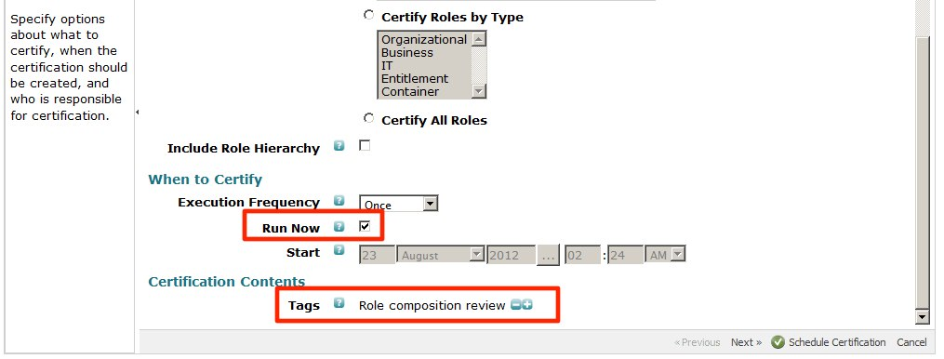

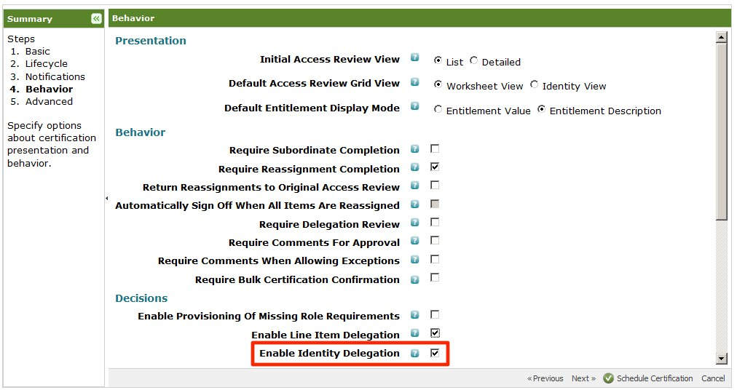

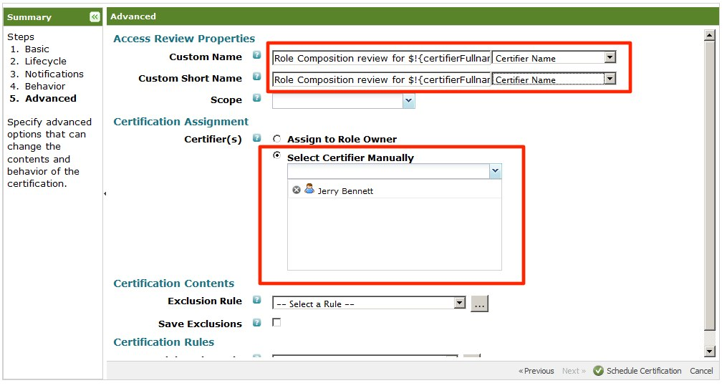

Additional options

You can extend the demo by adding an additional entitlement to the “Data Analyst Access” role so you can revoke that as well and show the different options in the work item for revocation at the end.

Snapshot the Machine

If using VMware Workstation/Fusion, shutdown the virtual machine and take a snapshot to allow restore to the demo point.

The Role Certification Demonstration

Demo startup

1. Open up different Firefox browser sessions and log in as the following players:
   1. Jerry Bennett (Leave the session at his Dashboard)

The Role Certification Demo Scenarios

1. In the Jerry Bennett browser, click on the “Role Composition review for Jerry Bennett” item in your inbox.
   1. Click on the “Accounts Payable Accountant” business role
      1. Click on the “Finance & Accounting” Inherited role.  
           
         Explain this is a container object and approve it
      2. Click on the “Accounts Payable Access” role and approve it as it seems appropriate
      3. Click on the “Accounting General Access” Permitted role  
           
         Explain the Entitlement Rule the role contains displays the actual access rights granted through inheritance to all members of the “Accounts Payable Accountant” business role.  
           
         Somehow this seems inappropriate to you for the “Accounts Payable Accountant” business role, so Revoke it
      4. Click “Save Changes”
   2. Go back to the List View
   3. Click on the “Accounts Payable Access” IT role
      1. Click on the “Entitlements for Account on Active Directory” link  
           
         Explain how we are now reviewing the IT role in detail. We already were able to view the actual entitlements while reviewing the Business role, but here we can actually revoke individual entitlements.
      2. Approve the Entitlement

History

|  |  |  |
| --- | --- | --- |
| Date | Changes | Comments |
| August 30, 2012 | Initial version |  |
| October 30, 2013 | Updated for 6.1 Demo scenario |  |